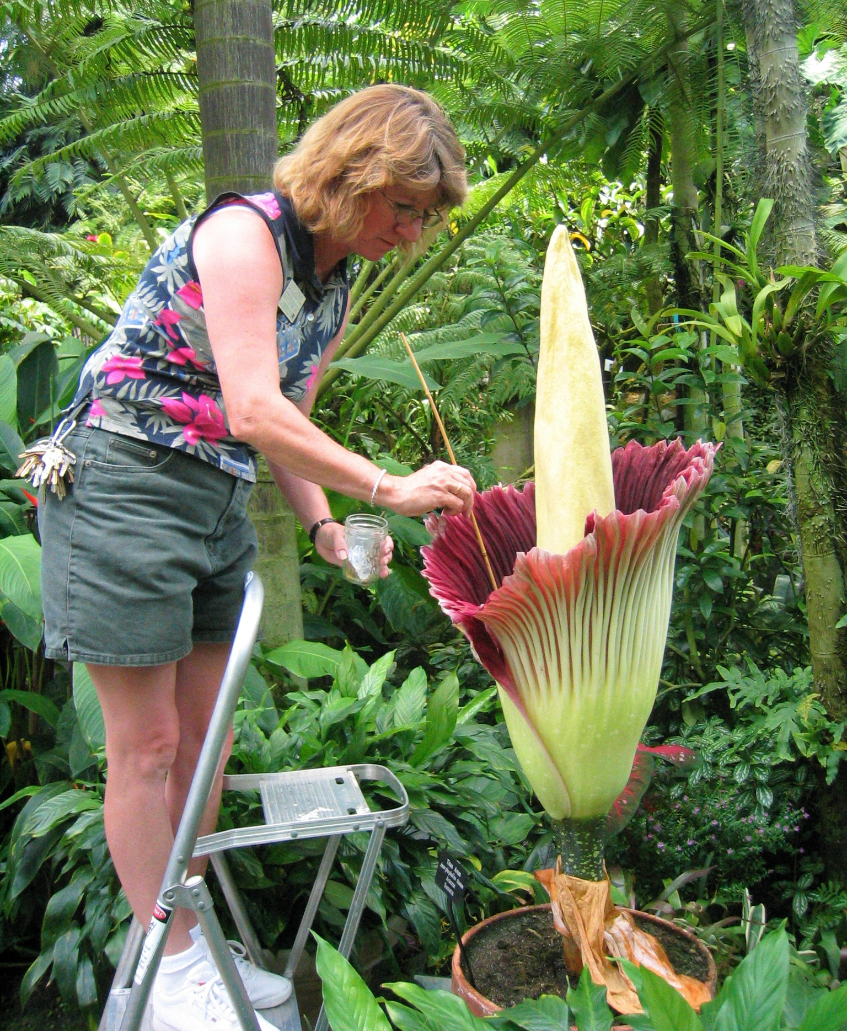

BIOLOGY 4354L/5354L Fall 2017

CRN 11499/11500 Tentative Syllabus

PLANT ANATOMY (LAB)* Dr. Jim Bidlack
All Sections: M W 4:00 - 6:50 PM 301B Howell Hall; Phone: (405) 974-5927
Howell Hall: Room 154 E-mail: jbidlack@uco.edu
http://www.metabolism.net/bidlack/ Office Hours: M W 2:00 - 3:50 PM
http://biology.uco.edu/bidlack/ or by appointment

PLANT ANATOMY LAB: This is a three-hour per week laboratory to accompany BIO 4354/5354.

*All students must attend PLANT ANATOMY LECTURE. It meets on Mondays and Wednesdays from 4:00 to 6:50 PM in Room 154 of Howell Hall.

Laboratory Textbook: Amiet, C.F., and J.E. Bidlack. 2017. Laboratory Guide to Plant Anatomy. Fourteenth Edition. Available in class.

Lab Date Lab topic Point value

August
1 23 The Microscope and Plant Cell Structure 10
2 30 General Anatomy and Morphology 10

September
6 Lecture Today – No Lab
3 13 Cell Types and Tissues 15
4 20 Xylem 15
5 27 Phloem 15

October
6 4 Vascular Architecture 15
7 11 Primary Roots 15
8 18 Primary Stems 15
9 25 Primary Root and Stem Development 15

November
10 1 PART 1: Secondary Growth 7.5
11 1 PART 2: Wood Anatomy 7.5
12 8 Leaves 15
13 15 Trichomes, Secretory Structures, and Idioblasts 15
22 Thanksgiving Holiday
14 29 Reproductive Structures and Life Cycle 15

December
15 6 PART 1: Seeds and Seedlings 7.5
16 6 PART 2: Fruits 7.5

11-15 FINAL EXAMINATIONS

TOTAL POINTS 200

Lab Reports must be handed in BEFORE CLASS on the meeting day following completion of the experiment. Summaries of research papers discussed during lab periods should be stapled to the front of the lab report and will be used in determining total points awarded for each report.

LABORATORY REPORTS

BIOLOGY 4354L and 5354L

PLANT ANATOMY LAB

1. Lab reports are required and must be handed in BEFORE CLASS on the day the report is due.

2. Reports will be graded on the basis of completeness, clarity, and creativity.

3. Points, as listed on the tentative laboratory syllabus, will be used for the value of each report. The total value for all lab reports is 200 points.

4. Format for your lab reports will be as follows:

Article Summary (if needed): Write a one-page synopsis of the article and issues discussed during class. Staple this summary to the front of your report.

Title: Try to convey the objective of the experiments in a brief title. For example, "Use of the Microscope and Generalized Cell Structure."

Introduction: Briefly explain the purpose of the experiments and give the reader an idea of practical applications. This should be about 1 to 4 sentences in length.

Results and discussion: This section should be written to enable the reader to conceptualize observations, drawings, tables, graphs, and other figures presented in the report. DRAWINGS SHOULD INCLUDE THE NAME OF THE SPECIMEN DRAWN, SECTION VIEWED, AND MAGNIFICATION. All results should be neatly presented in an easy-to-read, straight-forward, and entertaining manner. Highlight the major points of each experiment and provide your interpretation of results. This is the most important part of your laboratory report.

Conclusions: Briefly summarize (less than 5 sentences) key concepts and explain why they are important in studying plant anatomy. Tell what you learned from your investigations.

5. Ease of reading, neatness, and entertainment value, all contribute towards excellent lab report grades. Make the report enjoyable to read and provide an explanation of what you learned in the Conclusions section.

