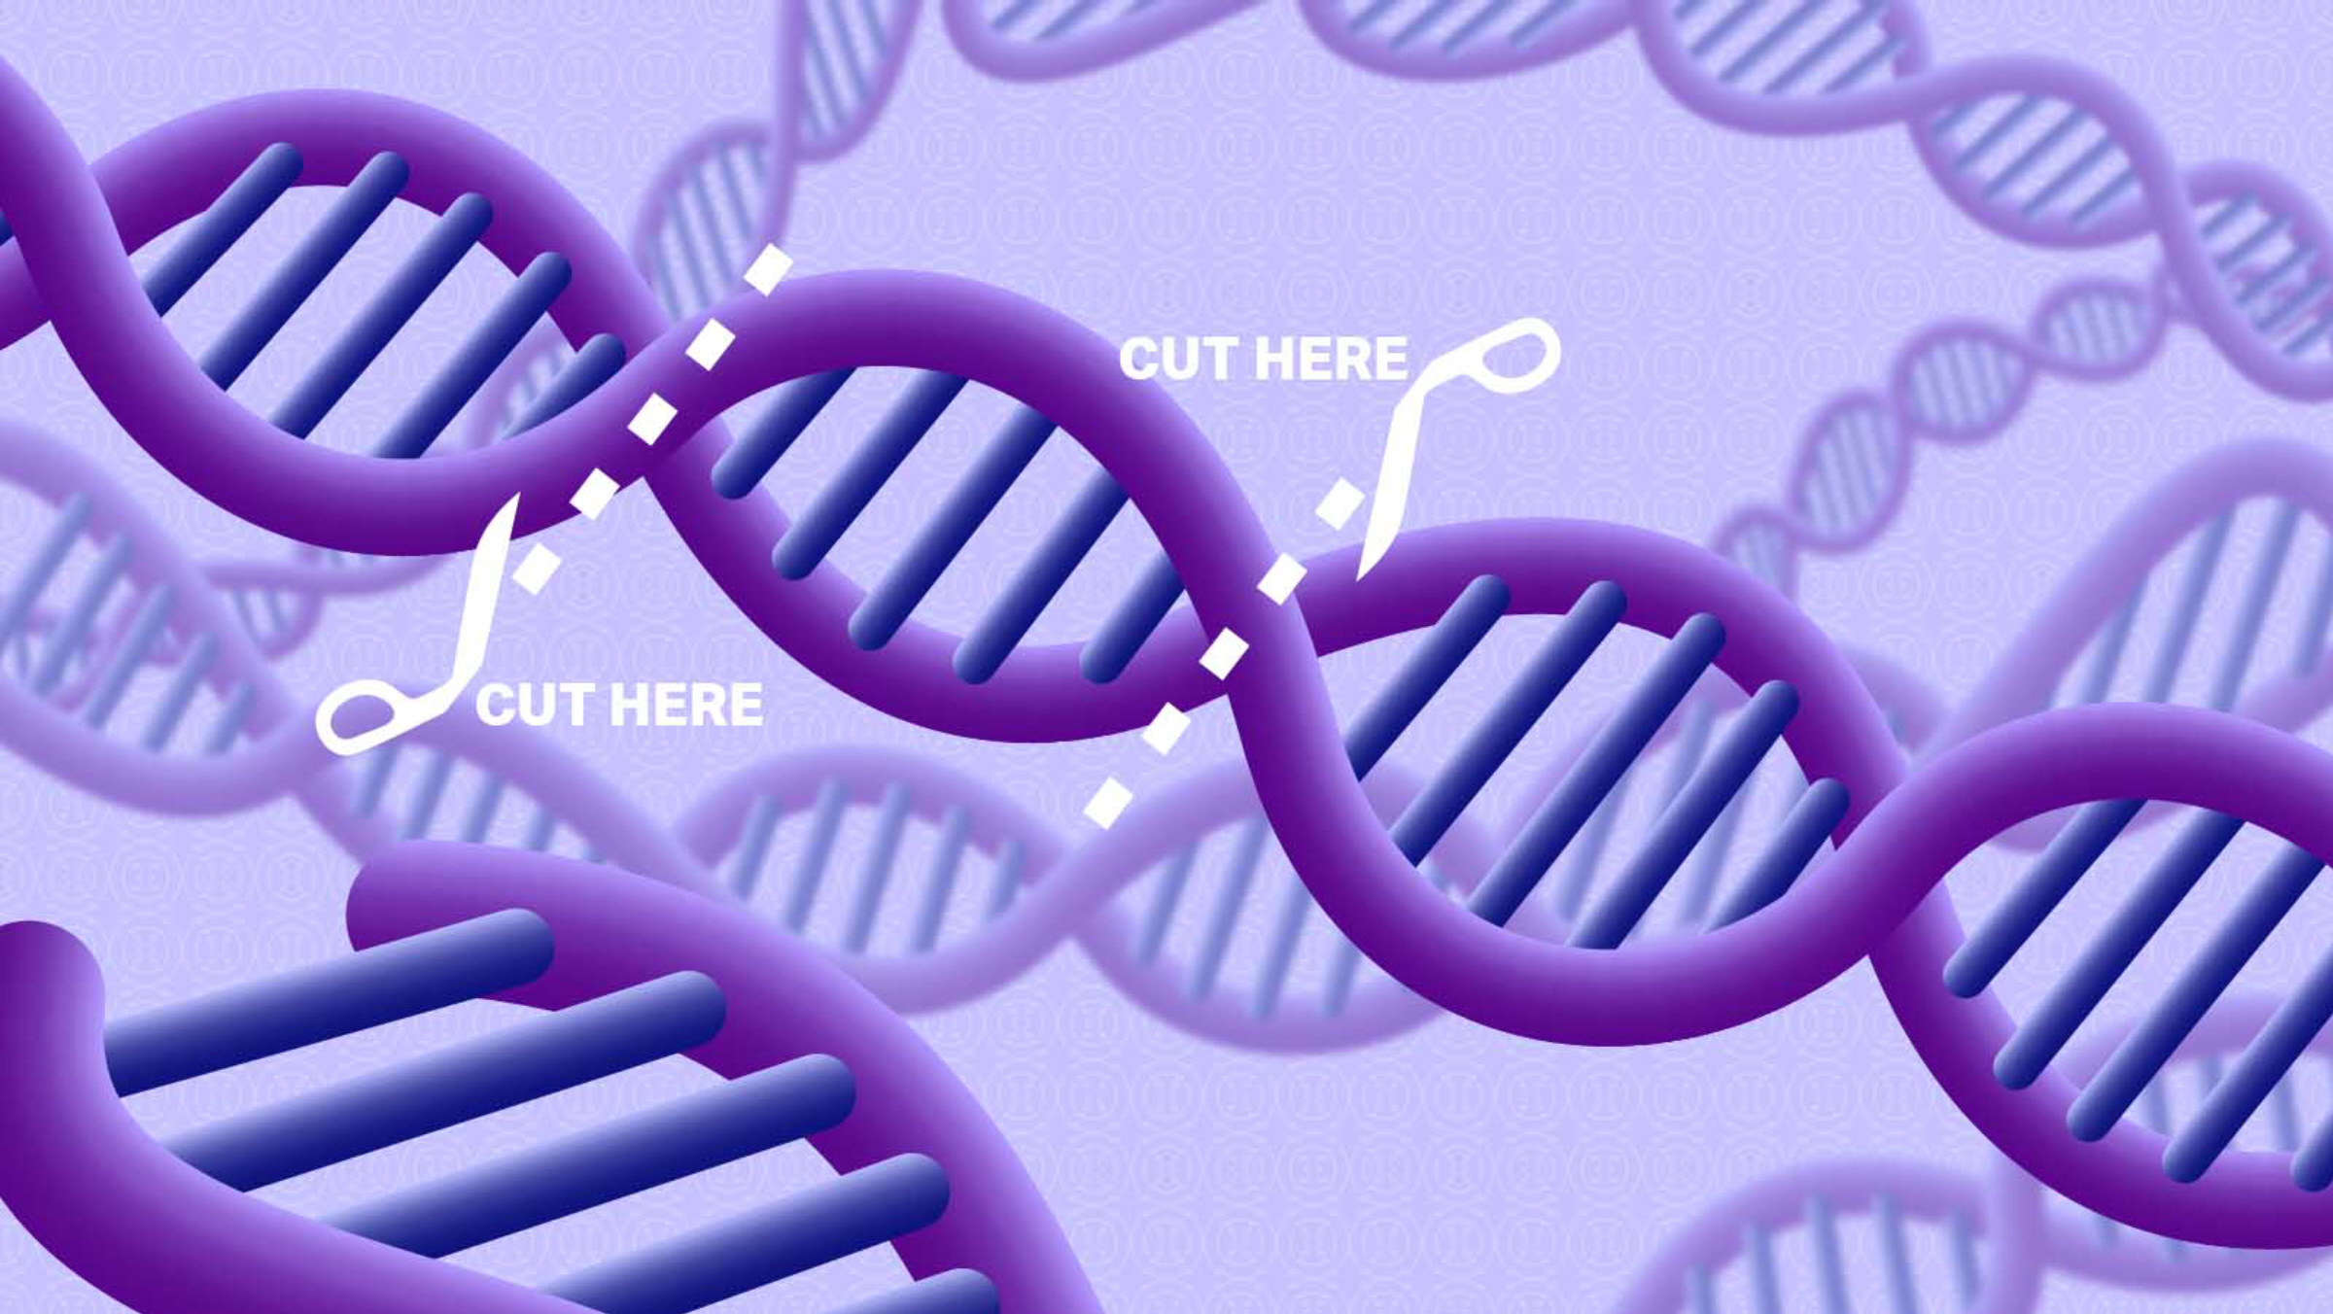

BIOLOGY 4454/5454 Fall 2022 CRN 15907/15908 Tentative Syllabus

MOLECULAR CELL PHYSIOLOGY AND LAB Dr. Jim Bidlack
CRN 15907/15908: M W 10:00 AM - 12:50 PM 301B HOH (Howell Hall - Office)
257 HOH (Laboratory Annex Building) Phone: (405) 974-5927 http://www.metabolism.net/bidlack/ E-mail: jbidlack@uco.edu
https://www3.uco.edu/centraldirectory/profiles/2120 Office Hours: MTWR 12:50 - 1:50 PM
https://achieve.macmillanlearning.com/ or by appointment
Textbook Course ID is: qy7nxt

MOLECULAR CELL PHYSIOLOGY: A study of the molecular and physiological aspects of cell life. Topics include cell dynamics, protein structure and function, nucleic acids, recombinant DNA technology, subcellular organization, photosynthesis, respiration, integrated metabolism, transport, and differentiation. The course consists of lecture and laboratory integrated into six hours per week; length of laboratory sessions varies with weekly topics. Prerequisites: 12 hours of Biological Science (including Cell Biology) and Organic Chemistry.

Date Lecture / Laboratory Topic Chapter

August
22 M Cell structure and function 1,4
24 W Chemical foundations: general chemistry 2

29 M Biological molecules 2
31 W LAB 1: DNA Isolation

September
5 M Happy Labor Day!
7 W Biological molecules / protein structure and function 2,3

12 M Protein structure and function 3
14 W Protein structure and function 3

19 M Protein structure and function 3
21 W EXAM I

26 M Protein synthesis: Molecular genetic mechanisms 5,6
28 W LAB 2: Protein Electrophoresis

October
3 M Protein synthesis: Molecular genetic mechanisms 7,8,9
5 W Biomembranes and subcellular organization 10,11

10 M Biomembranes and subcellular organization 10,11
12 W Biomembranes and subcellular organization 10,11

Date Lecture / Laboratory Topic Chapter

October (continued)
17 M LAB 3: Organelle Isolation and Enzymology
19 W Biomembranes and subcellular organization 10.11

24 M Control of gene expression 7,8
26 W Control of gene expression 7,8

31 M RNA processing, nuclear transport, and post-translational control 8,9

November
2 W LAB 4: Transformation and Gene Expression

7 M RNA processing, nuclear transport, and post-translational control 8,9,11,13
9 W EXAM II

14 M Photosynthesis 12
16 W Cellular Respiration 12

21 M LAB 5: CRISPR Technology or PCR Analysis
23 W Happy Thanksgiving!

28 M Additional metabolic pathways 12
30 W Molecular genetic techniques and genomics 6,7,8

December
5 M Molecular genetic techniques and genomics 6,7,8
7 W Additional exam material

12-16 FINAL EXAMINATIONS

CRN (15907/15908): The Final Exam (EXAM III) is scheduled for Friday, 16 December at
9:00 - 10:50 AM.

Additional course information: Students are encouraged to read the book before coming to class. Review what pages will be discussed in lecture by looking at the pictures, figures, and illustrations. Browse the information and then move on to reading the text to acquaint yourself with the learning material. PowerPoint presentations produced by the publisher as well as PowerPoint presentations developed by students during previous semesters are available at http://www.metabolism.net/bidlack/

The Central Six
At the University of Central Oklahoma, we are guided by the mission of helping students learn by providing transformative experiences so that they may become productive, creative, ethical and engaged citizens and leaders contributing to the intellectual, cultural, economic and social advancement of the communities they serve. Transformative learning is a holistic process that places students at the center of their own active and reflective learning experiences. A student's major field is central to the learning experience and is a vital part of the "Central Six." All students will be transformed with Discipline Knowledge, Leadership, Problem Solving (Research, Scholarly and Creative Activities), Service Learning and Civic Engagement, Global and Cultural Competencies, and Health and Wellness.

BIOLOGY 4454/5454
MOLECULAR CELL PHYSIOLOGY AND LAB
Fall 2022 – CRN 15907/15908
Instructor: Dr. Jim Bidlack
Office Phone: (405) 974-5927 UCO Weather Line: (405) 974-2002
E-Mail: jbidlack@uco.edu
Internet http://www.metabolism.net/bidlack/ or https://www3.uco.edu/centraldirectory/profiles/2120
Office: MTWR 12:50 – 1:50 PM, 301B Howell Hall
Avoid Scheduling Office Visits Just Before Class

Textbook: Lodish, H., et al. 2021. Molecular Cell Biology. Ninth Edition. W.H. Freeman and Company, New York.

Attendance: Students are expected to attend all classes.

Grading: An approximate breakdown of points for the course is as follows:

3 lecture exams @ 100 points each 300
5 formal lab reports @ 30 points each 150
1 lab preparation @ 50 points* 50
1 presentation @ 50 points* 50
___________________________________________________________
TOTAL POSSIBLE POINTS 550

Grading scale Grade Points needed

90 -100% of total possible points A 495
80 -89% of total possible points B 440
70 -79% of total possible points C 385
60 -69% of total possible points D 330
Below 60% of total possible points F -

Exam material: Exam material will come from lecture, laboratory assignments, and the course textbook. For best performance, read the assigned text before attending lecture and review your notes after each class.

Exams: Translation dictionaries are not permitted during the exam. Exams will consist mostly of multiple-choice, matching, true-false, short answer, and short essay questions. All exams count in determining the final grade. Make-up exams will be given only in extenuating circumstances and will usually consist of long essay questions.

Cheating: All work should be that of the student alone. If the instructor determines that a student has cheated on an exam or any assignment, the student will receive no credit for that exam or assignment and the student’s name will be reported to the proper authorities.

*NOTE: Graduate students (BIO 5454) will be required to: 1) assist supervision of lab preparation and 2) accompany their presentation with a short report (250 word minimum and 2 references) about the topic.

For additional student information that accompanies this syllabus, go to the link on the Internet at:

https://www.uco.edu/academic-affairs/files/aa-forms/StudentInfoSheet.pdf

