Using The Nikon CoolPix 995 For Microscopic Photography
Plant Anatomy Fall 2006 (by Cliff Pelchat)

The document will serve as a guide for setting up the Nikon 995 camera for microscopic photography.

Attaching the Camera to the Microscope

- Remove the right eyepiece from the microscope by loosening the small Allen screw located around the bottom ring of the eyepiece using the supplied Allen wrench. Note: turning the small Allen screw counterclockwise loosens it and turning it clockwise tightens it. When replacing the eyepiece do not overly tighten the Allen screw. Only a small amount of pressure is required to secure the eyepiece to the microscope.
- Attach the eyepiece adapter to the camera by screwing (in a clockwise direction) it to the threads located around the camera lens. Be careful not to strip the threads. The adapter should turn easily onto the threads. You can make sure the threads are aligned properly by turning the adaptor in a counter clockwise direction about ½ of a rotation while resting it against the lens threads. You will feel the adapter align to center indicating that you can begin turning in a clockwise rotation to screw it to the lens.
- Once the adaptor is attached to the camera, slide the barrel of the adaptor into the eyepiece tube to mount the camera on the microscope.
  - You may tighten the Allen screw to secure the camera so that the field of view is upright and the camera is aligned at a right angle to the eye tube.

Camera Settings (these are the settings that have given me the best results)

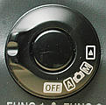
- Turn the camera on by turning the mode-dial located to the right of the top LCD panel to M for manual.
Manual setting

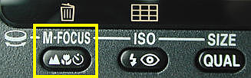
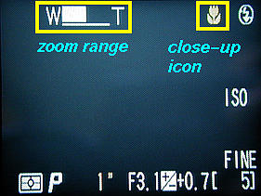
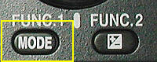
- Select the focus as close-up by pressing the focus mode button, labeled M-Focus, until a flower icon appears in the monitor. Use the zoom range control to zoom in until the flower icon turns yellow. This will place the camera in macro mode and allow for the sharpest focus. See below:

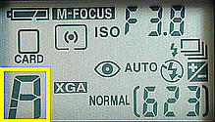
- Use the Mode button located on top of the camera in conjunction with the command dial to set the camera to Auto-Aperture (A) mode. An A in the bottom left of the monitor indicates that you are in aperture mode. Note that it will cycle between P, S and A. The illustration above shows the P setting. You will also see an A appear in the Control Panel as illustrated below.
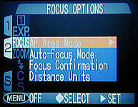
- Press the Menu button on the back of the camera twice to access the user’s settings menu. Select the AF Area mode in the sub-menu of the Focus option as illustrated below.

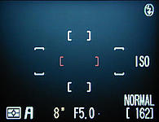
- Using the multi-selector located to the right of the monitor screen you will be able to select one of 5 bracketed focus areas. The area selected will produce the sharpest area of focus for the picture. Usually this will be the center bracket. You can also use the Command dial to dial in the highest F-stop, which will increase the depth-of-field and help to sharpen the picture. See the illustration below. Notice that F5.0 has been selected.

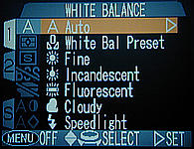
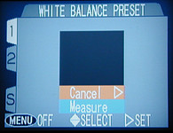
- Insert a piece of lens paper into the field of view on the microscope stage. Select the White Balance Preset option from the user menu and select the Measure option in the Preset sub-menu then press the Multi-selector to the right until you hear a beep. See the illustration below.

Once the camera is setup the settings will not change as long as there is a charged battery or external power applied to the camera. Press the shutter release lightly and observe the picture in the monitor. If the picture focuses in and appears the way you want then fully depress the shutter to record the picture. Be careful not to jerk the camera while depressing the shutter. It will take some practice to get the camera to focus properly because the camera’s focusing sensor relies on incoming light. Sometimes the field of view will focus to a small circle. If this happens turn the camera off and on to M mode again. This resets the camera light sensing element and allows it to auto focus.

Keep in mind that the larger the F number you have the sharper the final picture will be.

