Jim Bidlack - BIO 3204

PLANT PHYSIOLOGY Lecture 14 - Nitrogen and Sulfur Metabolism

I. Importance of nitrogen and sulfur metabolism
A. Nitrogen and sulfur are abundant in plants
1. Nitrogen is the fourth most abundant after C, H, and O
a) Present as protein (amino acids) and chlorophyll
b) Present in amides, nucleotides, and nucleoproteins
2. Sulfur is pretty important too
a) Present as part of protein (in cystine, cysteine, and methionine)
b) Present in glutathione, coenzyme A, and some vitamins
II. Example of metabolic trace - nitrogen metabolism

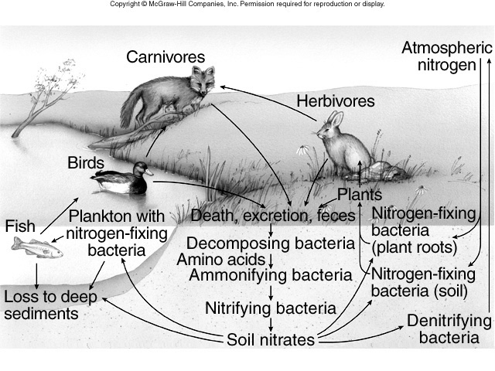

III. Example of integrated metabolism - sulfur metabolism

