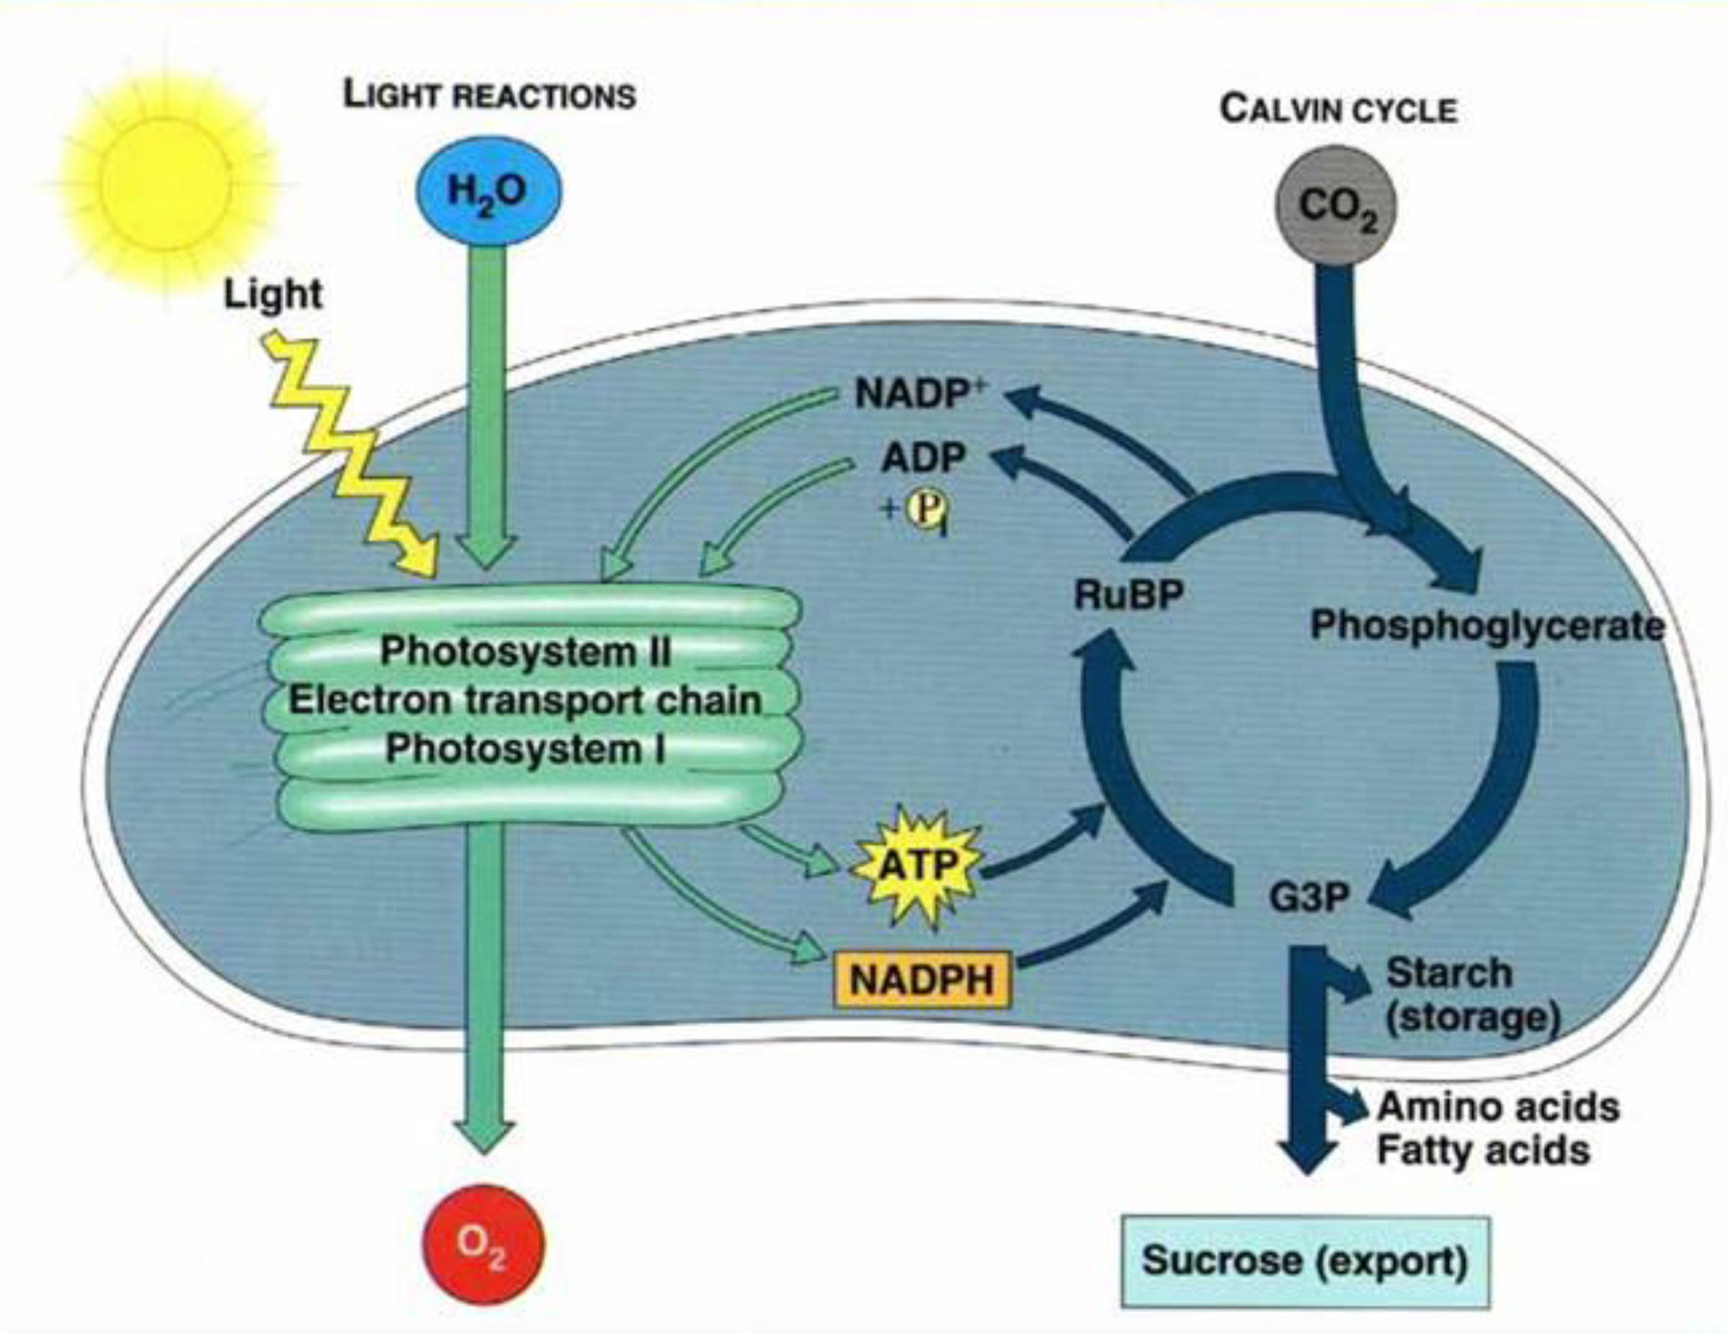
BIOLOGY 3024 Spring 2023
CRN 20917 Revised Syllabus

PLANT PHYSIOLOGY (LAB)* Dr. Jim Bidlack
CRN 20917: M W 10:00 AM - 12:50 PM 301B HOH (Howell Hall - Office)
257 HOH (Lab Annex Building) and (maybe) Zoom 255 HOH (Lab Annex Building - LAB)
Phone: (405) 974-5927
https://bidlack.net/ or https://www.metabolism.net/bidlack/ E-mail: jbidlack@uco.edu
https://www3.uco.edu/centraldirectory/profiles/2120 Office Hours: MTWRF 1:00 - 2:00 PM or by appointment

*All students must attend PLANT PHYSIOLOGY LECTURE. It also meets Mondays and Wednesdays from 10:00 AM to 12:50 PM.
PLANT PHYSIOLOGY: This course provides an introductory investigation of vascular plant physiology. Topics include photosynthesis and respiration, secondary metabolism, mineral nutrition, and plant growth regulation. The course consists of three hours lecture and three hours laboratory per week. Prerequisite(s): BIO 1225, 2203, one of the following (3054, 3543, 3703, 3303) and STAT 2103 all with a minimum grade of "C."

Lab Date Lab topic Experiment Pages (in Manual)

January
25 Laboratory preparation and
additional exam material

February
1. 1 Pipetting, pH, and buffers 1 4

2. 8 Spectrophotometry 2 5-6

3. 15 Centrifugation and protein determination 3 7-8

4. 22 Photosynthesis: Hill reaction 4 9-11

March
5. 1 Tetrazolium test for dehydrogenase activity 5 12

6. 8 Malate dehydrogenase in soybean 6 13-15
Part one: Planting

7. 22 Malate dehydrogenase in soybean 6 15-16
Part two: Organelle isolation

8. 29 Malate dehydrogenase in soybean 6 17
Part three: Protein and MDH
April
9. 5 Malate dehydrogenase in soybean 6 18-21
Part four: SDS-polyacrylamide electrophoresis
Lab Date Lab topic Experiment Pages (in Manual)

April (continued)
10. 12 Plasmolysis 7 22

11. 19 Water potential 8 23-24

12. 26 Minerals and nutrient deficiencies 9 25-27

May
13. 3 Plant growth regulators 10 28

14. 3 Tissue culture 11 29

GRADING AND DUE DATES FOR LAB REPORTS

Lab Due date Points

1 2/8 10
2 2/15 10
3 2/22 20
4 3/1 30
5 3/8 20
6-9 4/12 100
10 4/19 20
11 4/26 30
12 5/3 30
13 5/3 (in class) 20
14 5/3 (in class) 10
__________________________________________

TOTAL 300

Summaries of research papers or proposals discussed during lab periods should be stapled to the front of the lab report and will be used in determining total points awarded for each report.

LABORATORY REPORTS
BIOLOGY 3024, CRN 20917
PLANT PHYSIOLOGY LAB

There is a computer room (Science Computer Lab) located in Howell Hall that you may use for writing lab reports. It is generally open 8:00 AM to 5:00 PM MTWRF.

1. Lab reports are required and must be handed in BEFORE LAB on the day the report is due.

2. Reports will be graded on the basis of completeness, clarity, and creativity.

3. Points as listed on the tentative laboratory syllabus will be used for the value of each report. The total value for all 14 lab reports is 300 points. That is 300 out of the total 700 points allocated for the course, or 42.9% of the final grade.

4. Format for your lab reports will be as follows:

Article Summary (if needed): Write a one-page synopsis of the article and issues discussed during class. Staple this summary to the front of your report.

Title: Try to convey the objective(s) of the experiments in a brief title.

Introduction: Briefly explain the purpose of the experiments and give the reader an idea of practical applications. This should be about 1 to 4 sentences in length.

Procedure: Provide a summary of methodology. Make it short and simple. Briefly explain how equipment and specimens were used. This section should be less than one paragraph in length.

Results and Discussion: This section should be written to enable the reader to conceptualize observations, tables, graphs, and other figures presented in the report. All results should be neatly presented in an easy-to-read, straightforward, and entertaining manner. Highlight the major points of each experiment and provide your interpretation of results. This is the most important part of your laboratory report.

Conclusions: Briefly (less that 5 sentences) summarize key concepts and explain why they are important in studying plant physiological processes. Tell what you learned from your investigations.

5. The ease of reading, neatness, and entertainment value all contribute towards excellent lab report grades. Make an attempt to make the report enjoyable to read and make a special effort to explain what you learned in the conclusions.

