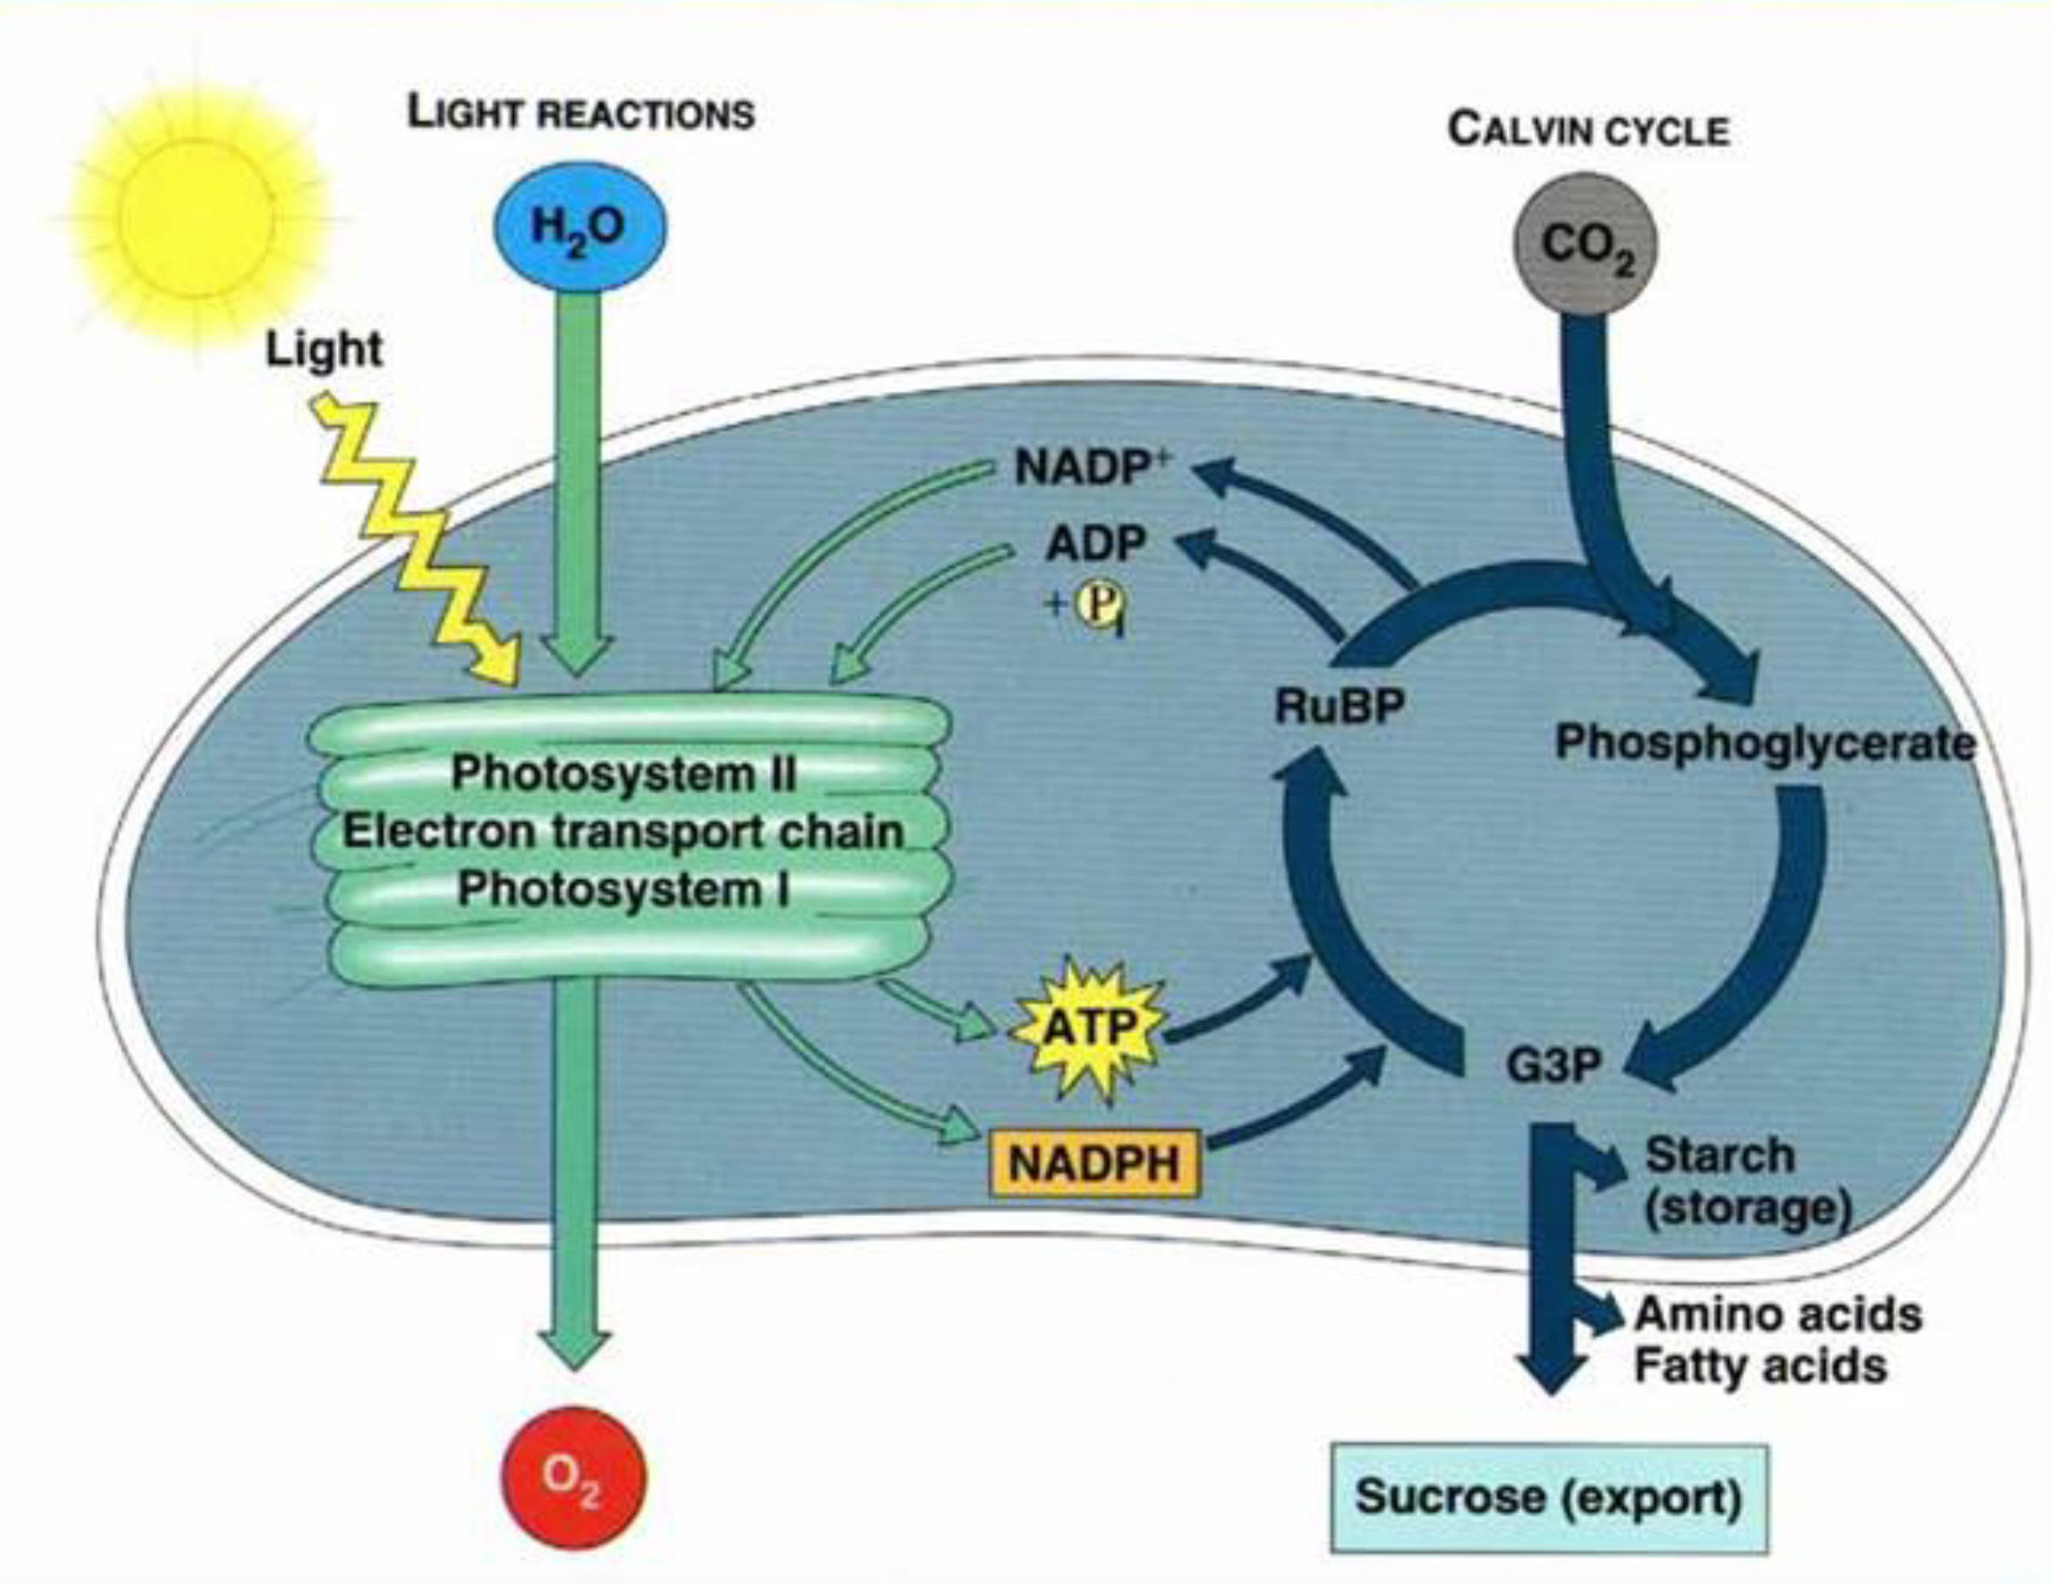
BIOLOGY 3024 Spring 2023
CRN 20917 Revised Syllabus

PLANT PHYSIOLOGY (LECTURE)* Dr. Jim Bidlack
CRN 20917: M W 10:00 AM - 12:50 PM 301B HOH (Howell Hall - Office)
257 HOH (Lab Annex Building) and (maybe) Zoom 255 HOH (Lab Annex Building - LAB)
Phone: (405) 974-5927
https://bidlack.net/ or https://www.metabolism.net/bidlack/ E-mail: jbidlack@uco.edu
https://www3.uco.edu/centraldirectory/profiles/2120 Office Hours: MTWRF 1:00 - 2:00 PM or by appointment

*All students must attend PLANT PHYSIOLOGY LAB. It also meets Mondays and Wednesdays from 10:00 AM to 12:50 PM.
PLANT PHYSIOLOGY: This course provides an introductory investigation of vascular plant physiology. Topics include photosynthesis and respiration, secondary metabolism, mineral nutrition, and plant growth regulation. The course consists of three hours lecture and three hours laboratory per week. Prerequisite(s): BIO 1225, 2203, one of the following (3054, 3543, 3703, 3303) and STAT 2103 all with a minimum grade of "C."

Date Lecture topic Chapter Pages

January
16,18 MW MARTIN LUTHER KING HOLIDAY
Introduction, levels of organization 1 1-10
Inorganic and organic chemistry lecture notes
Biological molecules (Part I) 1,7,8 11-13,180-190,
206-207,226-227
23,25 MW Biological molecules (Part II) 11,12 292-295,321,
343-346
lecture notes

30,1 MW Plant cells, anatomy, & physiology 1,14 1-49,379-495
Overview of metabolism lecture notes

February
6,8 MW LIGHT RXNS: Photosynth. - light capture 7 171-185
LIGHT RXNS: Photosystems I and II 7 185-202

13,15 MW DARK RXNS: CO₂ fixation - Calvin cycle 8 203-220
DARK RXNS: C-3, C-4, and CAM plants 8 220-244

20,22 MW EXAM I
Other aspects of photosynthesis 9,10 245-268,269-284
Additional exam material

The Central Six: At the University of Central Oklahoma, we are guided by the mission of helping students learn by providing transformative experiences so that they may become productive, creative, ethical and engaged citizens and leaders contributing to the intellectual, cultural, economic and social advancement of the communities they serve. Transformative learning is a holistic process that places students at the center of their own active and reflective learning experiences. A student's major field is central to the learning experience and is a vital part of the "Central Six." All students will be transformed with Discipline Knowledge, Leadership, Problem Solving (Research, Scholarly and Creative Activities), Service Learning and Civic Engagement, Global and Cultural Competencies, and Health and Wellness.
Date Lecture topic Chapter Pages

February (continued)
27,1 MW Structure & function of enzymes 13 358-361
Glycolysis 12 317-324
Krebs (TCA) cycle 12 326-329

March
6,8 MW Electron transport. & oxid. phosphoryl. 12 329-340

13,15 MW SPRING BREAK

20,22 MW Pentose phosphate & respiration perspective 12 324-326,340-352
Nitrogen and sulfur metabolism 13 353-376

27,29 MW Secondary metabolism 23 693-729
Plant molecular biology 1,2,15 13-25,51-79,
407-445

April
3,5 MW EXAM II
Thermodynamics, water potential 3 83-98
Xylem transport 4 99-118

10,12 MW Plant nutrition 5,6 119-142,143-168
Phloem transport and partitioning 11 285-316
Photosynthesis-transpiration compromise 4,10 110-118,269-284

17,19 MW Growth and development 17,18 477-511,513-552
Plant growth regulation - Part 1 19,20 553-623
Plant growth regulation - Part 2 21,22 625-692

24,26 MW EXAM III
Photomorphogenesis 16 447-476
Photoperiodism 20 597-605
Responses to temperature 9,20,24 255-264,605-608,
736-737

May
1,3 MW Circadian rhythms, geotropism 5,16,18,20 133-137,467,
528-534,594-597
Environmental and stress physiology 24 731-761

12 F FINAL EXAMINATION

The Final Exam is scheduled for Friday, 12 May 2023 at 9:00 - 10:50 AM. The final exam is scheduled for the last day of finals week. What a great opportunity to study!

BIOLOGY 3024
PLANT PHYSIOLOGY AND PLANT PHYSIOLOGY LAB
Spring 2023 - CRN 20917

Instructor: Dr. Jim Bidlack
Office Phone: (405) 974-5927 UCO Weather Line (405) 974-2002
E-Mail: jbidlack@uco.edu
Internet: https://bidlack.net/ or https://www.metabolism.net/bidlack/
Office (or Zoom): MTWRF 1:00 - 2:00 PM, 301B Howell Hall
Avoid Scheduling Office Visits Just Before Class

Lecture Textbook: Taiz, L., E. Zeiger, I. Moller, and A. Murphy. 2015. Plant physiology and development.
6th edition. Sinauer Associates, Inc., Publishers, Sunderland, MA.

Lab Textbook: Bidlack, J. E. 2023. Plant physiology laboratory manual. 18th edition. As well as exercises from MERLOT (https://merlot.org).

Grading: An approximate breakdown of points for the course is as follows:

3 lecture exams @ 100 points each 300
1 final exam @ 100 points 100
Lab reports and article summaries 300
____________________________________________________________________
TOTAL POSSIBLE POINTS 700

Grading scale Grade Minimum points needed

90 - 100% of total possible points A 630
80 - 89% of total possible points B 560
70 - 79% of total possible points C 490
60 - 69% of total possible points D 420
Below 60% of total possible points F -

Exam material: A majority of exam material will come directly from lecture. For best performance, read the assigned text before attending lecture and review lecture notes after each class. Study your notes carefully and review the major topics provided in the text prior to each exam.

Exams: NOTE: Alternative exams (essay exams) may be implemented if there is a resurge of the COVID-19 Pandemic and instructions will be provided in class. Semester exams, quizzes, and the final exam will consist of mostly short answer and essay with some fill-in-the-blank, multiple-choice, matching, and true-false questions. All exams count in determining the final grade. Make-up exams will be given only in extenuating circumstances and will usually consist of long essay questions.

Cheating: All work should be that of the student alone. No communication, notes, or wireless devices are permitted during any exam. If the instructor determines that a student has cheated on an exam or any assignment, the student will receive no credit for that exam or assignment and the student’s name will be reported to the proper authorities.

For additional student information that accompanies this syllabus, go to the link on the Internet at:

https://www.uco.edu/academic-affairs/files/aa-forms/StudentInfoSheet.pdf

